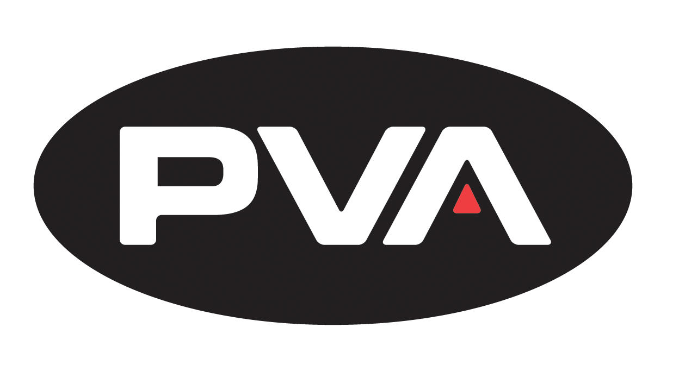

**Organization:**

Precision Valve and Automation

**Position:**

Automation Systems Programmer

**Job Description:**

Design, implement and debug software on motion control systems and PLC platforms. The candidate will work closely with the hardware and software used for a variety of robotics and automation tasks. Candidate will be expected to handle multiple projects at once while adhering to strict deadlines.

**Required Skills:**

Programming foundation required; Computer Science, Computer Programming, or Engineering related degree preferred. Candidate must be motivated and willing to learn

**Company Information:**

World Class Dispensing, Coating and Custom Automation. When precision matters, manufacturers around the globe rely on PVA's conformal coating systems, fluid dispensing solutions and custom automation products. For 20 years, PVA has been making manufacturing easier with customer driven solutions used in industries ranging from solar, semiconductor packaging, printed circuit board assembly, medical device manufacturing, and consumer electronics. From benchtop equipment, to inline conveyor systems, we evaluate each opportunity independently, and without limitation, to ensure you make the most reliable product possible.

**Contact Information:**

Ryan Winne

[RWinne@pva.net](mailto:RWinne@pva.net)

Systems Programming Group Manager

www.pva.net